**A REPORT**

**ON**

**(University Website of BMU)**

**By**

Name: Enrolment/Registration No.

Tripathi Shivam Raghavesh 1800268C203

## Prepared in the partial fulfillment of the

Practice School II Course

# AT

**(Verzeo (Inmovidu Technologies Pvt. Ltd), Bangalore)**

A Practice School II Station of



##### BML MUNJAL UNIVERSITY

**(July, 2020)**

**Table of Contents**

|  |  |  |
| --- | --- | --- |
| **Serial No.** | **Topic** | **Pages** |
| **1** | Certificate | **3** |
| **2** | Declaration | **4** |
| **3** | Acknowledgement | **5** |
| **4** | Objective | **6** |
| **5** | Problem Statement | **7** |

|  |  |  |
| --- | --- | --- |
| **6** | Company Profile | **8** |
| **7** | Flow chart | **9** |
| **8** | Assumptions made | **10** |
| **9** | Methodology used | **11** |
| **10** | Functionalities | **14** |
| **11** | Results and Discussion | **15** |
| **12** | Code | **28** |
| **13** | Conclusion | **29** |
| **14** | References | **30** |

**Certificate of Completion**

CERTIFICATE

This is to certify that Practice School Project of Tripathi Shivam Raghavesh titled

Website of University (BMU) is an original work and that this work has not been

submitted anywhere in any form. Indebtedness to other works/publications has been duly acknowledged at relevant places. The project work was carried during 25th May 2020 to 4th July 2020 in Verzeo

|  |  |
| --- | --- |
|  |  |
| **Signature of PS-II faculty** | **Signature of industry mentor/Supervisor** |
| **Name:Dr. Rajesh Yadav** | **Name: Mrs . Ruchika Gupta** |
| **Designation: Professor** | **Designation:**  Head of Operations,  Inmovidu Technologies Pvt. Ltd |
| ***(Seal of the organization with Date)*** | ***(Seal of the organization with Date)*** |

**DECLARATION**

I hereby declare that the composition "Website of University (BMU)" submitted for the Full time BTECH Degree at BML Munjal University School of Engineering is my unique work and the thesis has not shaped the reason for the honor of any degree, cooperation or some other comparable titles

**Student Name:** Tripathi Shivam Raghavesh

**Signature:**  

**Acknowledgement**

Motivation and inspiration have plays important role in achieving any endeavor.

I express my true gratitude to Dean SOET, Vice chancellor and Co-Ordinator's of PS program.

I pay my profound feeling of appreciation to my mentor Dr. Rajesh Yadav of Computer Science dep., BML Munjal University, Gurgaon to encourage me and to give me the Guidance to set up the project. I would like to thank my friends for motivation, empowering direction, and kind management in the finish of my undertaking.

I feel to recognize my obligation and profound feeling of appreciation to my guide Mrs. Ruchika Gupta whose important direction and kind management given to me all through the Project which formed the current work as its show.

Last, however not the least, my parents are additionally a significant motivation for me. So, with due respects, I express my appreciations to them.

**Shivam Tripathi**

**Objective**

To nurture the knowledge on basic web development frontend part and backend part and to implement the knowledge of HTML 5, CSS 3, JavaScript on an existing website. To remodel the frontend part and backend part through the Knowledge gained in the process of learning basic web development tools.

Further, porting the existing website into PHP, since we would like to utilize the power of server-side rendering vs client-side rendering as the content of the site is heavy. The basic idea to use PHP is that it will return HTML pages so that the page will load fast, as crawlers will get response quickly.

PHP can have approaches:

• Query database directly and return result is HTML.

PHP pages are saved as .php and returned as .html, the whole project is developed In PHP and HTML.

**Problem Statement**

To create a website of our university which contains various options and information regarding our university. Website contains the option like home page, courses page, campus life page, about page, contact page and registration page.

In each page detailed introduction is given about the university so that user will get the information about the university.

Registration page should be made in such a way that if any student wants to take admission in our university he or she can register through the given form and information will reach to the administrator and same thing goes with contact form if anyone want to enquire about university he or she can reach out by submitting the given form.

Footer part should be made in such a way that it should contain social media links and it should redirect to the particular page by clicking on the links. In course page entire thing is written about which course is offered in which specialization .

The aim of creating the website is to spread the information about university to the people and to guide the people about the university.

**Company Profile**

Verzeo is an AI-Based Online learning stage that gives understudies a comprehensive learning experience to help prepare them industry. With access to the Industry Experts, Online Courses and mixed learning, it permits understudies to Learn Here and Lead Anywhere. Degrees will in general show hypothetical ideas in study halls. Understudies graduate with vulnerable sides and positively no down to earth introduction to the activity condition. We, at Verzeo, overcome any barrier among study hall and working environment with our lead Internship Programs. We assist understudies with accomplishing progressively comprehensive instruction and set them up for better profession openings.

Verzeo goes about as an imperceptible coach to understudies, making channels to release their learning potential. It gives access to a wide assortment of preparing programs, hackathons, and ventures. These projects are intuitive, collective and offer access to tutors and specialists. With Verzeo, you can secure Internships and Position Opportunities flawlessly.

Verzeo has teamed up with specialized big shots to make a vivid stage. With AI-based programming at its center, it offers an associated environment available from anyplace and by anybody.

**Flow Chart for Registration**

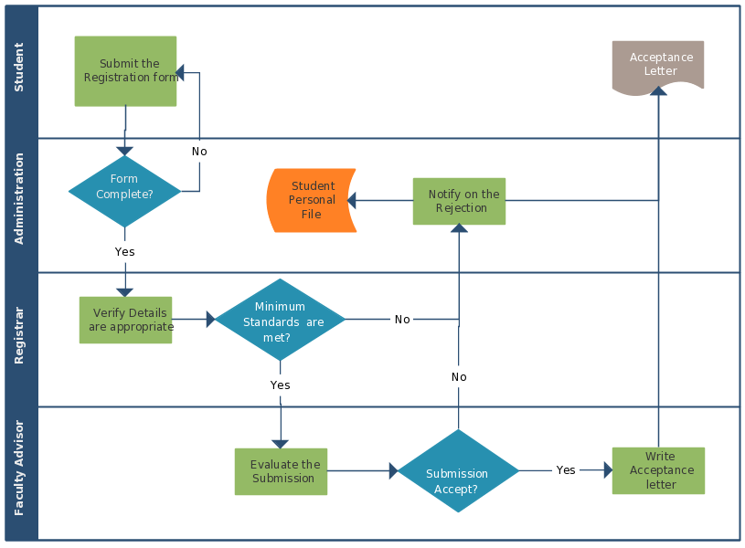

**Installing necessary software and files:**

* TEXT EDITOR
* XAMPP SERVER
* HTML
* CSS
* JAVASCRIPT
* BOOTSTRAP
* JQUERY WEBSITE DEVELOPMENT
* PHP
* MYSQL

**Assumptions made**

We thought of making our project on WordPress but due to following issues we made our website using HTML and CSS.

**Vulnerability**

The greatest drawback of WordPress is its safety. WordPress depends intensely on modules and topics for customization.

**WordPress Sites All Look the Same**

As a rule, except if your website specialist has altered your WordPress format, your webpage will most likely look conventional and fundamentally the same as each different WordPress webpage out there. In all actuality, numerous WordPress destinations are appealing, smooth, and cleaned up.

**Websites Need Maintenance**

Upkeep is a progressing issue with WordPress websites, because of updates, similarity issues, and security defects. Where a hand-coded site may never require month to month support, a WordPress site completely requires it, which can be costly over the long run.

**Customization needs Coding**

To roll out certain improvement your WordPress site, you need to have HTML, CSS and PHP information. In the event that you need to customize in a one of a kind way, or to upgrade its plan, you may end up expecting to compose various entangled code lines.

**Methodology used**

As the problems are listed above due to that reasons we made or website using HTML, CSS , PHP, MYSQL.

* HTML and CSS Coding language is used in front-end part. Html gives the a format to the context and meaning by displaying that context for example Heading, paragraph, Image etc. Whereas CSS is used to style the the body of website like to change the style of font or color
* For Back-end part PHP , MYSQL. is used. It connects the database with php so that whenever any user is writing the information in the form it will be shown in the myphpadmin to administrator.
* Different pages are created to make it simpler for the user to use and buttons are provided in the main page so that whenever we click on that button that page will open. so that it will be simple to access for user.
* In home page short information is provided about home , courses and campus life page and button is given at the end of the three section so that if anyone wants the more information about the particular thing by clicking on that button they can reach out to that page.
* For wallpaper and Leadership team part carousal is used to make it more attractive for the user.
* If any user is submitting the information from same email id the new window will automatically generate with the information “this email id is already register” with one email id only one user can submit the information.

**Method 1**

**Problem:** In starting I did everything in one page so it was very difficult for user to understand and the website was looking too complex

**Analysis:** So after looking on the problem i made some changes in that particular thing . on button was placed in every section so that it will redirect the user to the particular page.

**Solution:**

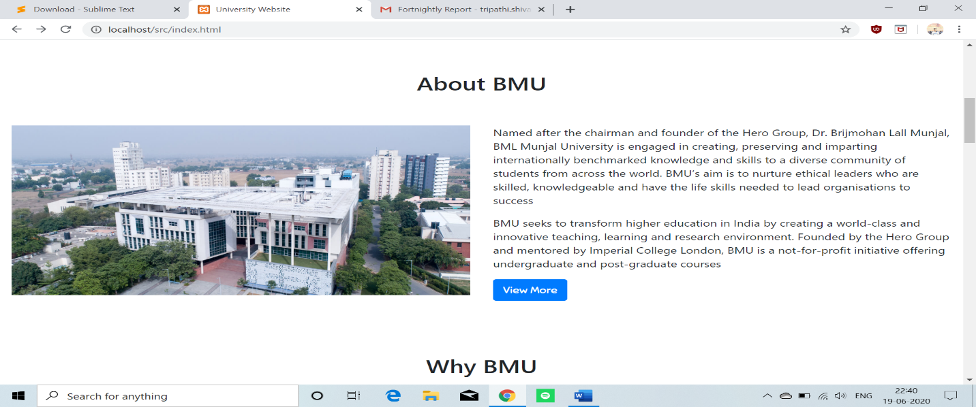

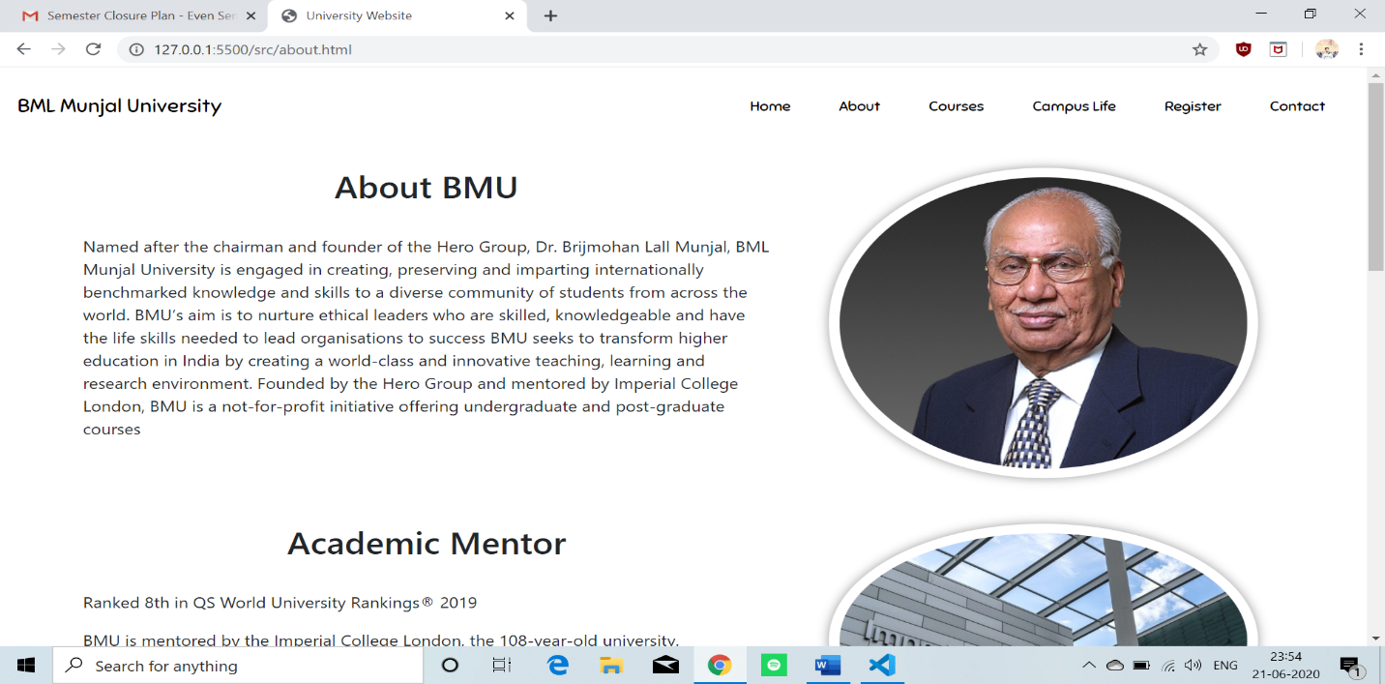

**Problem 2**

**Problem:** For backend part I wrote the code in PHP and linked that with MYSQL. and the data will be shown in MYPHP admin. I faced many problem in writing code in PHP because many new terms were there which I was not aware of.

**Problem 3**

After creating the database in MYSQL. the main problem was how to link that part with MYSQL. this was the main issue I faced. Many errors were generated after writing code.

**Solution:**

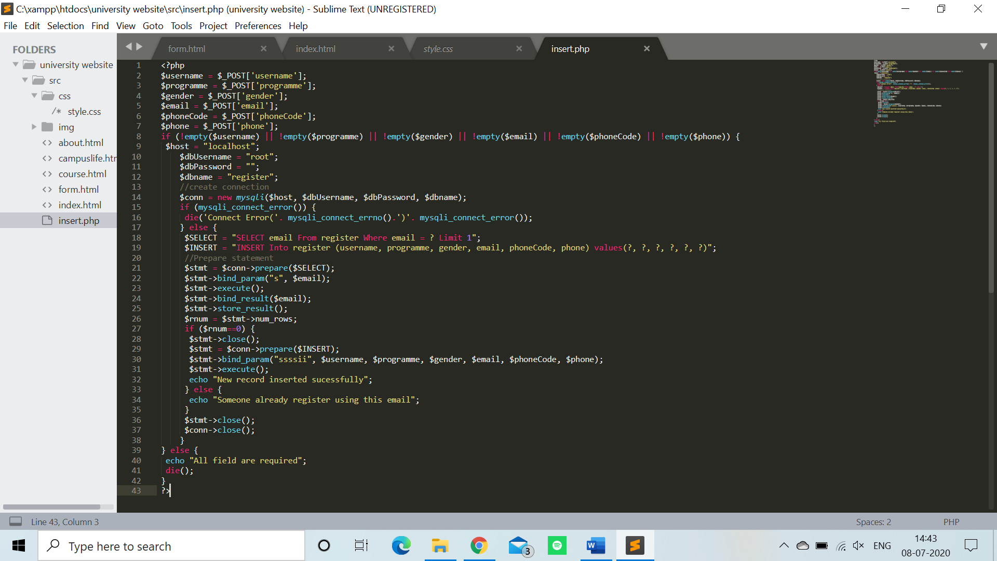

**FUNCTIONALITIES**

**TOOLS/LIBRARIES USED:** TEXT EDITOR: Sublime Text Editor, Atom.io, Microsoft Visual Studio Code.

**XAMPP SERVER:** XAMPP is a free and open-source cross-stage web server course of action stack group made by Apache server, containing generally of the Apache HTTP Server, Maria DB database, and interpreters for content written in the PHP and Perl programming language.

**HTML:** Html gives the format to the context and meaning by displaying that context for example Heading, paragraph, Image etc. HTML stands for Hypertext Markup Language and it is a standard markup language which is shown in an internet browser.

**CSS:** CSS stands for Cascading Style Sheets. CSS tells how HTML elements to be shown on computer screen or on any other platform. Because of CSS saves a lot of work when we do any project on web development. It handles the layout of many web pages at same time. External stylesheets are stored in CSS files.

**JAVASCRIPT:** JavaScript is a programming language. Which is one of the important part for the web development and JavaScript is use for the designing of both frontend as well as backend part.

**BOOTSTRAP:** Bootstrap is used to make website in less time. Bootstrap contain some template of HTML and CSS with the help of that we can link our website with that so that it saves our time it contains the template like Navbars, cards, buttons, tables, , image carousels, etc. We can link our bootstrap file with JavaScript.

**MYSQL:** MYSQL. is a platform which is use to create databases for companies, for any shopping website or for blood-donation camps etc. The most common use of MYSQL. is to create web databases.

**PHP:** PHP is a commonly used server-side programming language which became increasingly fast and important over the years. PHP works good with HTML and databases, making it a useful language for anyone interested in building dynamic web applications.

**Results and Discussion**

**Test Website Result**

Navigation Bar

* **Home link**: This link will take user to the home page
* **About link**: When any user will click on the about button about page will appear on the main screen and will show the details of university.
* **Course link**: It will give the information about the courses offered by university and the companies which offers the placement for students.
* **Campus life Link**: In this page the images of hostel, Infrastructure, facilities and which clubs are there in university will be shown.
* **Registration Link**: In this page a form is created in which after putting each and every detail which is required the information will come to admin

After navigation bar there is about page which have a short description of university and a button which will take you to about section.

After that there is why BMU section in which the student faculty ratio, number of students, corporate visits everything is shown.

In Courses part short description of each and every courses is given and a button is given it will open the courses section.

After course section Leadership team grid is shown in which President, chancellor, vice chancellors’ information is given and a short description about them and at last a contact form is there for any type of enquiry purpose.

**Home Page**

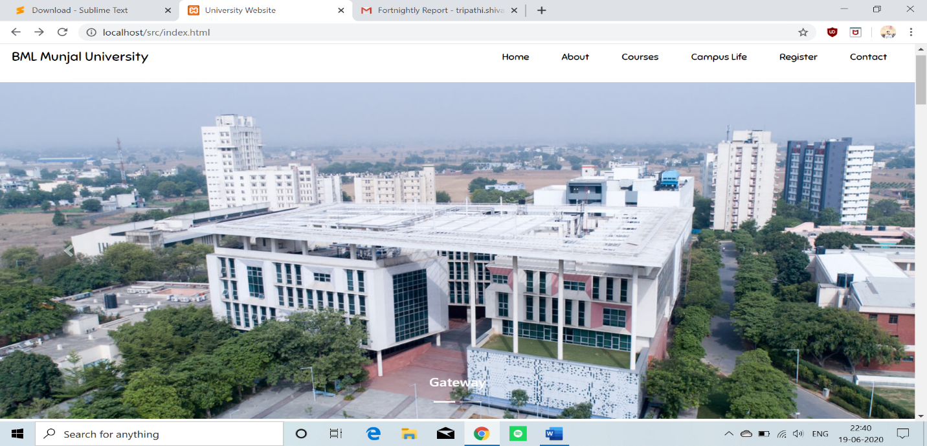

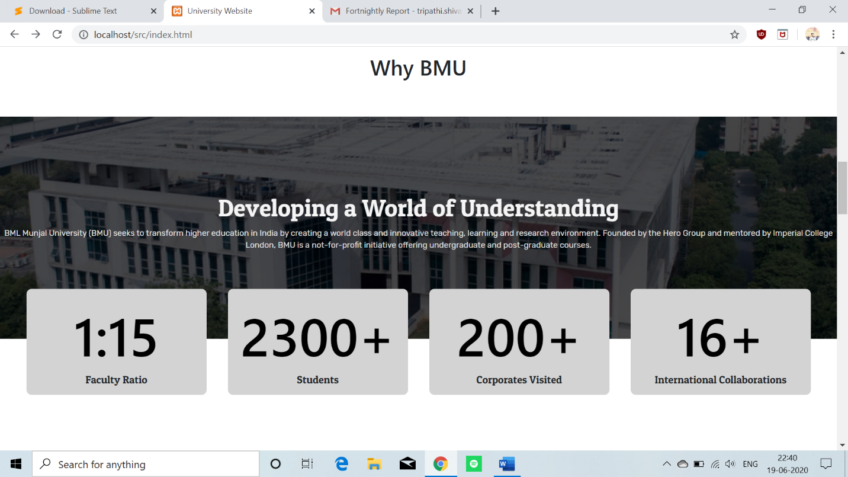

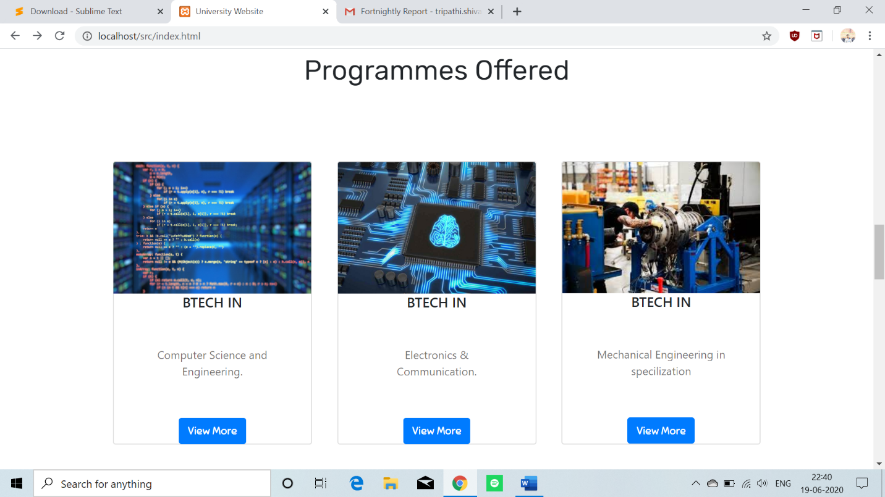

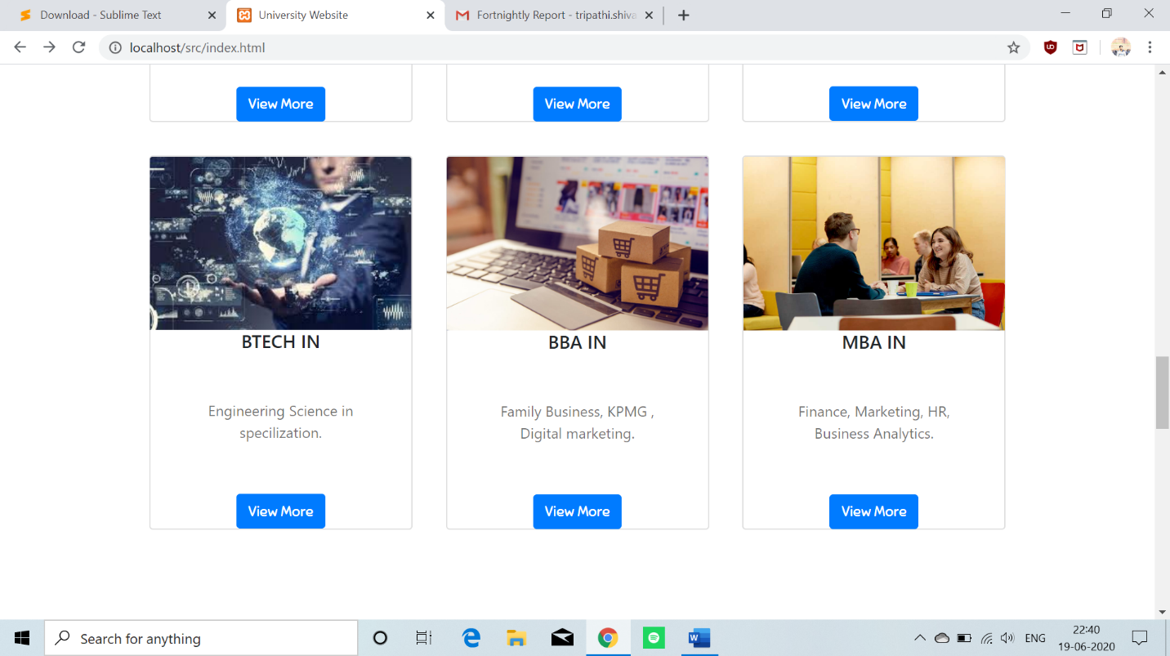

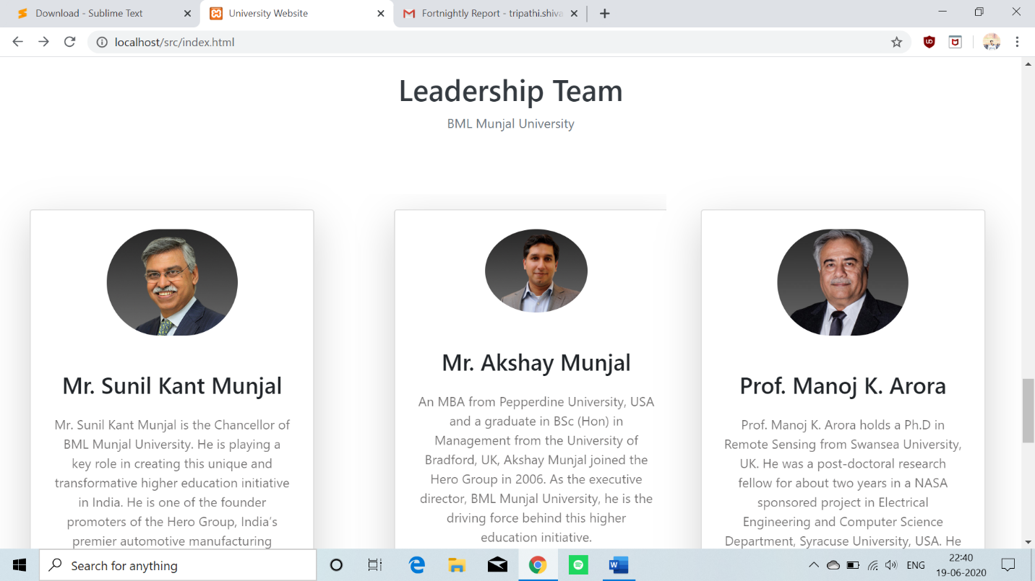

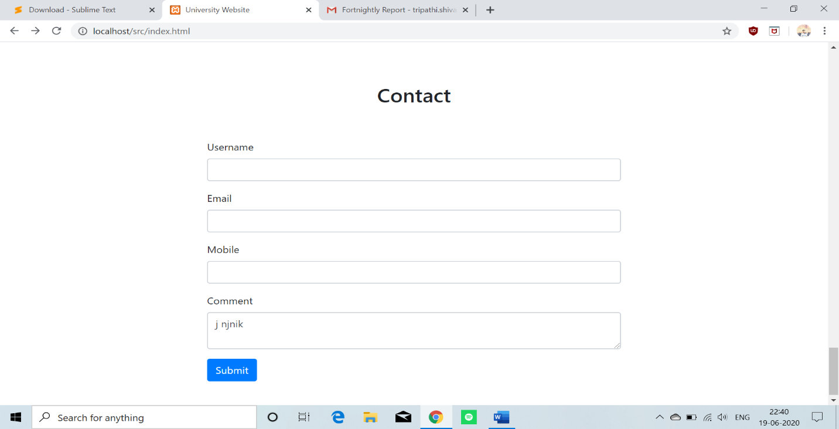

**Footer**

Footer contain social media icons like Facebook, twitter, Google+, LinkedIn and Instagram when user will click on any social media icon that particular page will open. So that user can check the social media handle of university.

Additionally, it contain short description of university and a Programs offered section and some shortcut links so that from footer also user can go to home or about or any other page. And one contact section is there which contain the email address of university (enquiry purpose). Contact no and address of university. At last a copyright section and Designed by section.

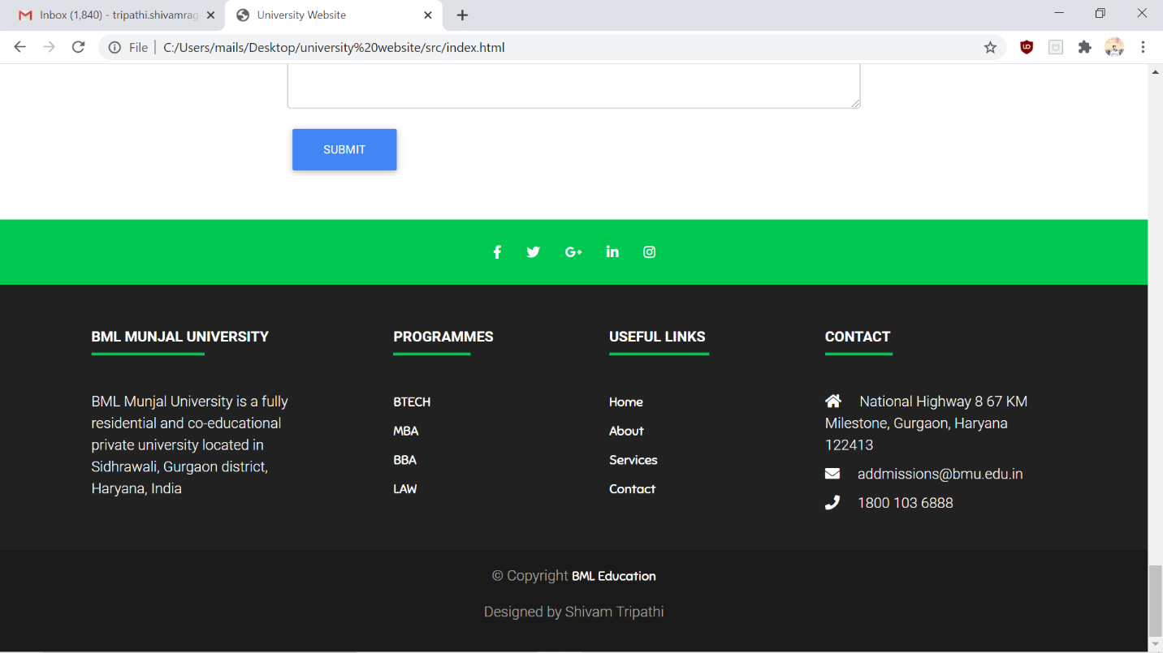

**Campus life Page**

In this page the life of campus is shown with the help of images. Information like which clubs are active in university. Logo and name of clubs are shown in this section

After that Infrastructure is given in that details of hostel is shown which type of hostel we can choose images of hostel, rooms are shown.

At last the facilities part is there were we can check which facilities are there in college like ATM, GYM, Cafeteria etc.

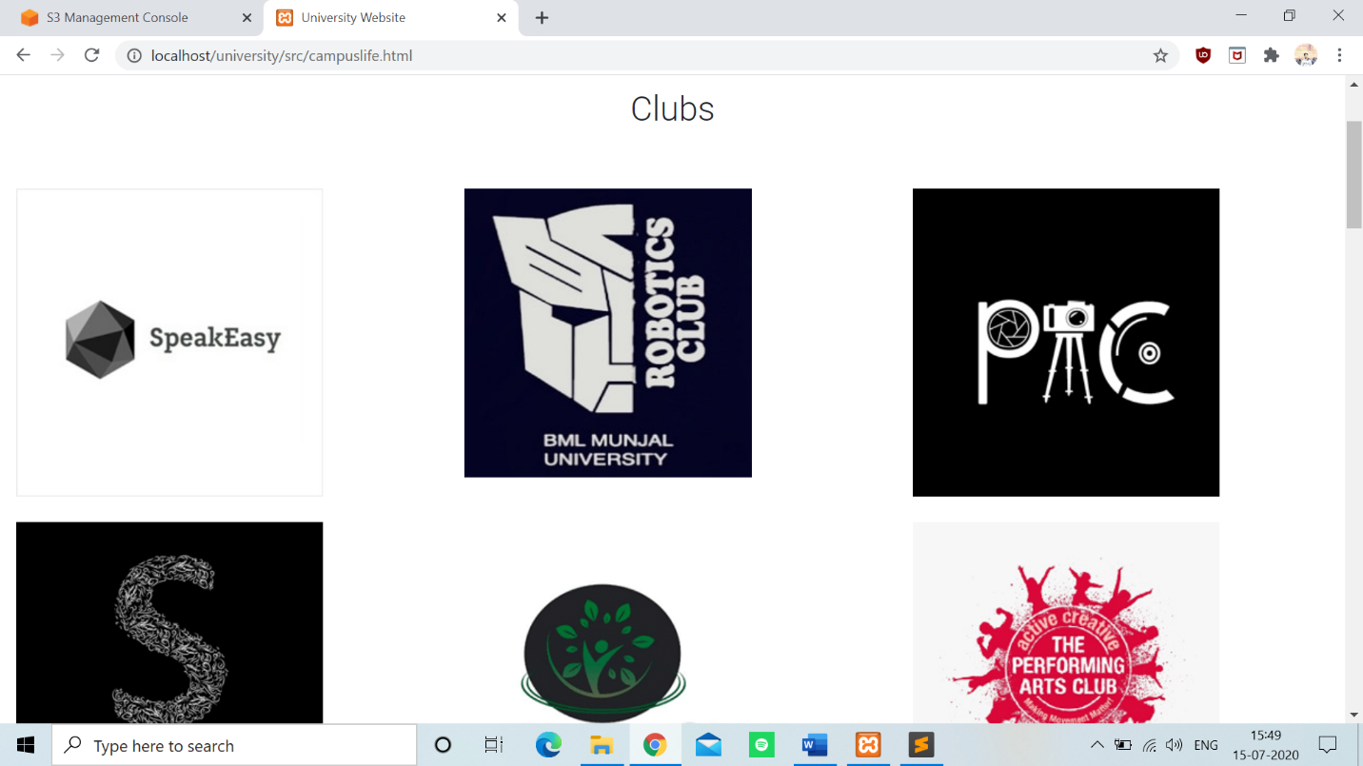

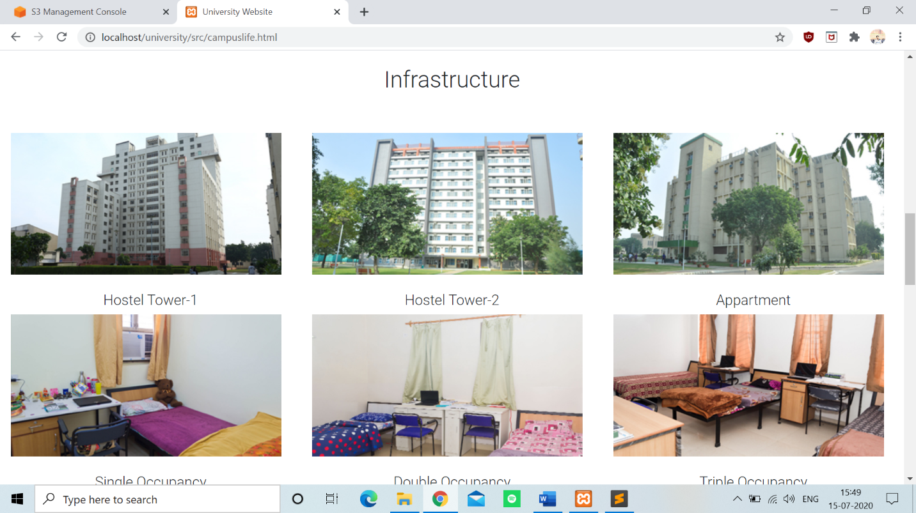

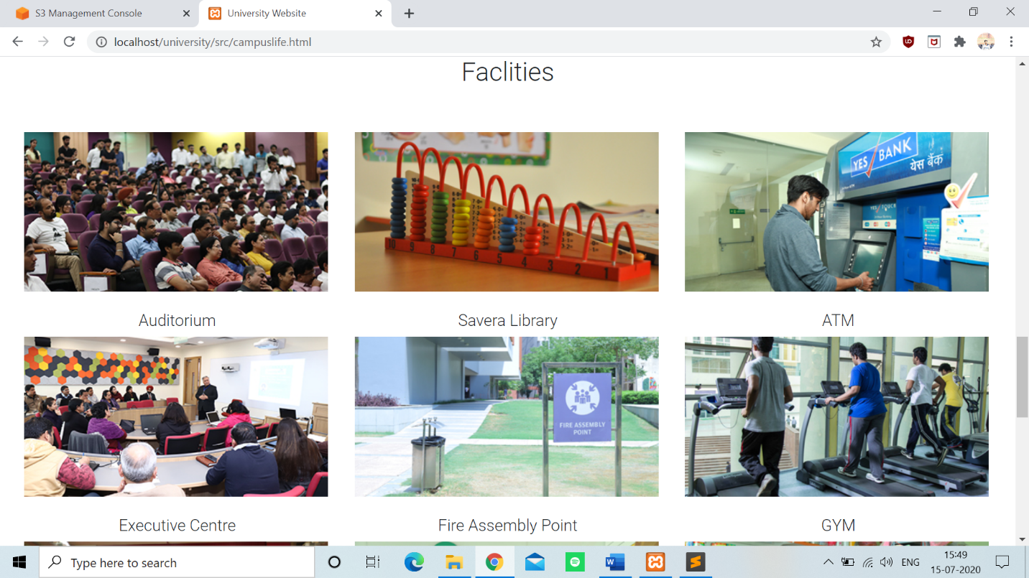

**Courses Page**

In this section the detail description of course is given which course is offered in which specialization which companies are visiting for hiring.

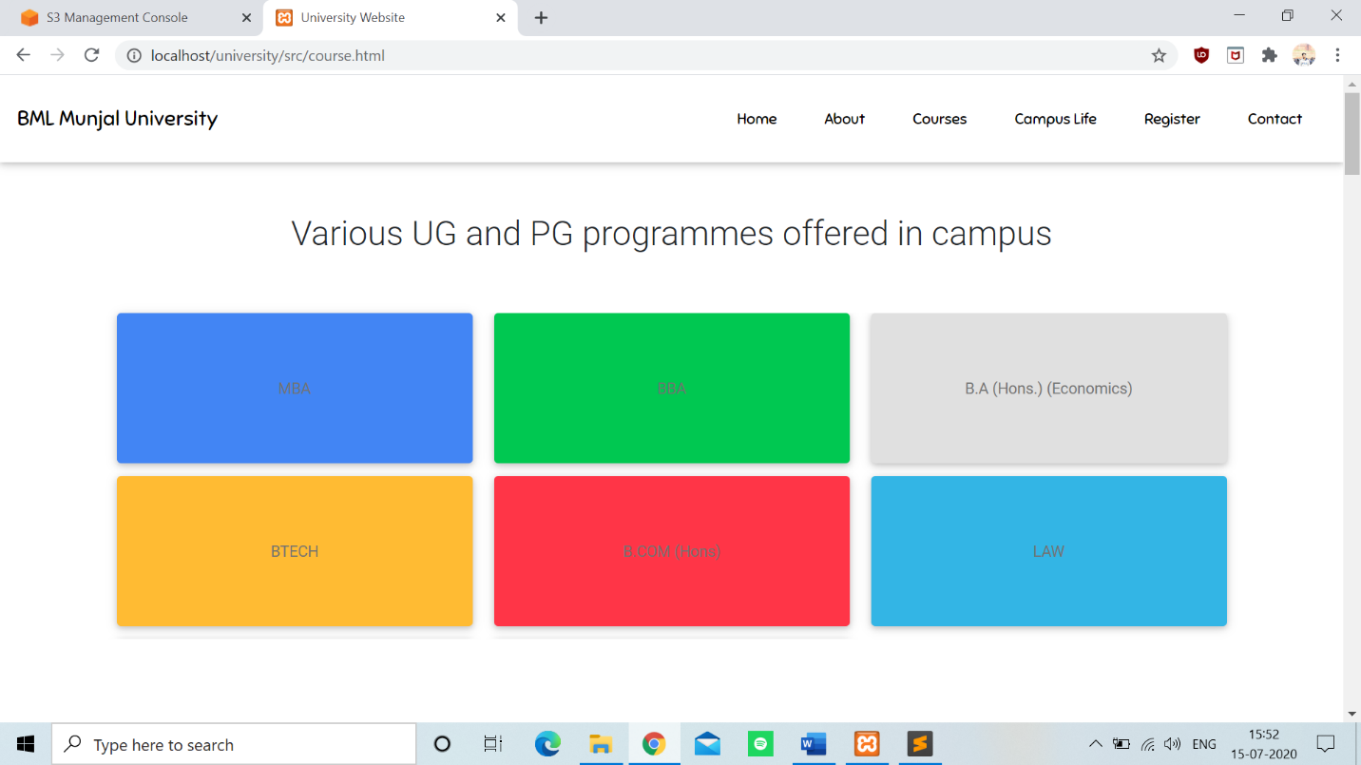

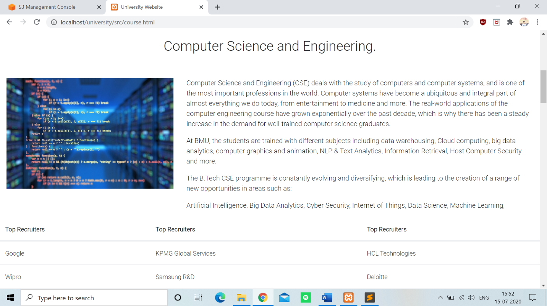

**About page**

In this section Complete information of college is given the founder of college academic mentor of college. And one highlight section is given in which when college was established and which type of university it is and accommodation type each and every information is there.

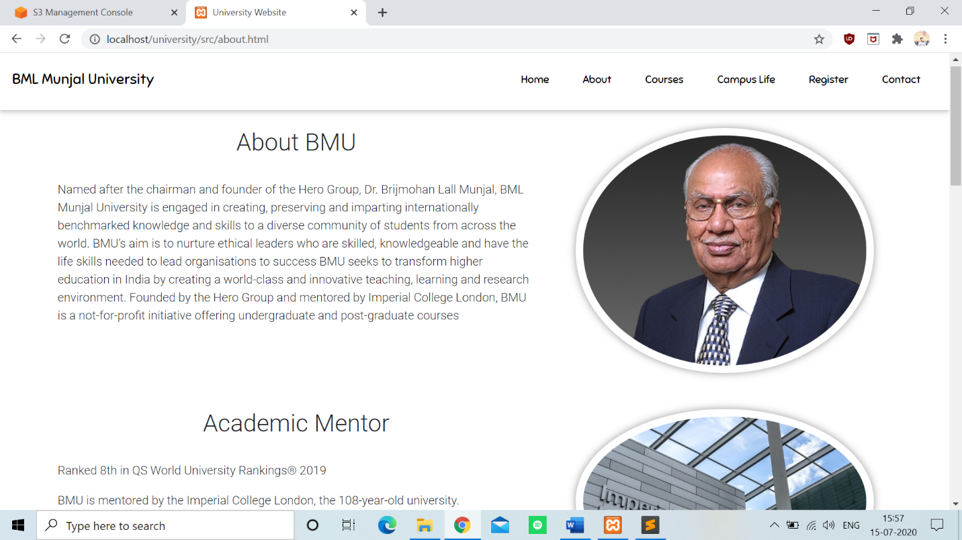

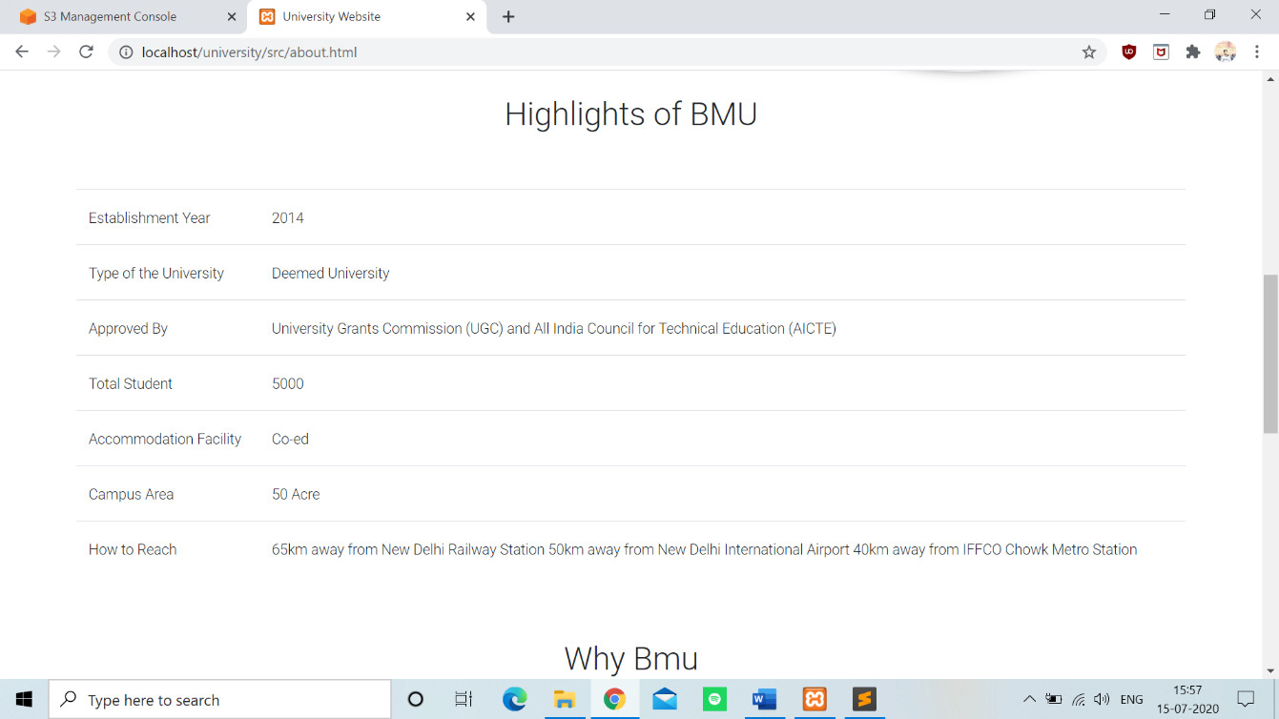

**PHP CODE**

In this section a form is created which include name, email-id, gender, program etc. After creating form a database is created using SQL. Which will take the information of user which he will input in that form and it is linked with PHPMYADMIN so that whenever any user will write the information admin will able to access the information of user.



**Registration sample**

For the better understanding example of the form is shown in the screenshot how admin can see the info of user.

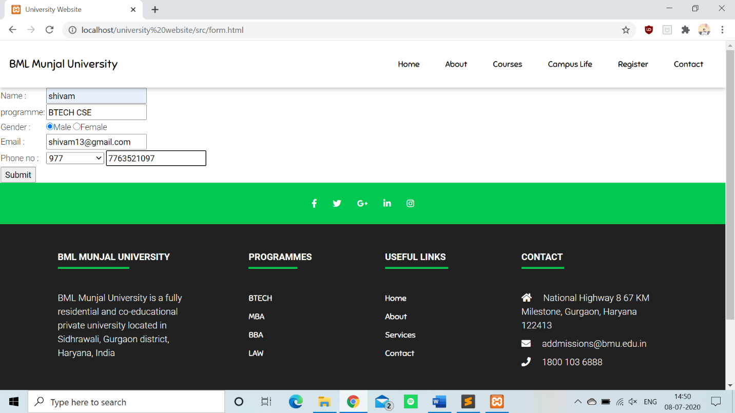

**Registration sample output**

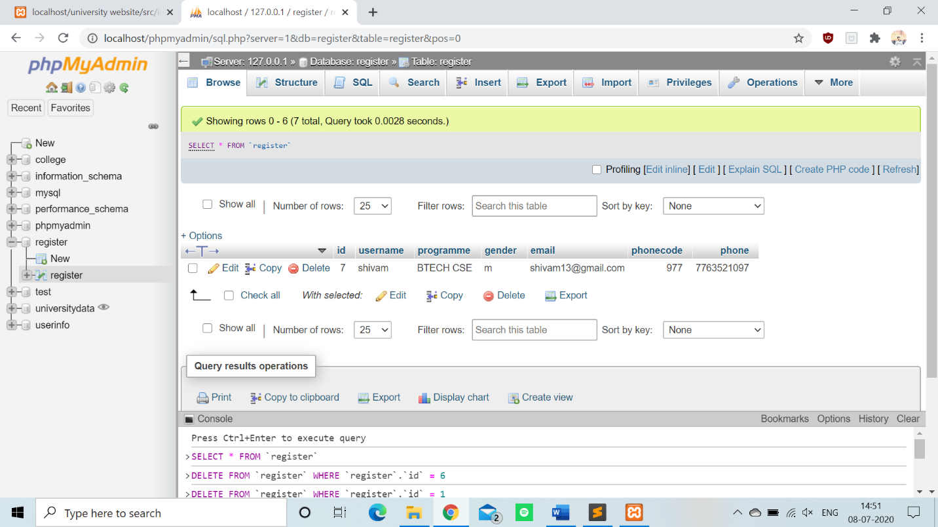

**Test Code**

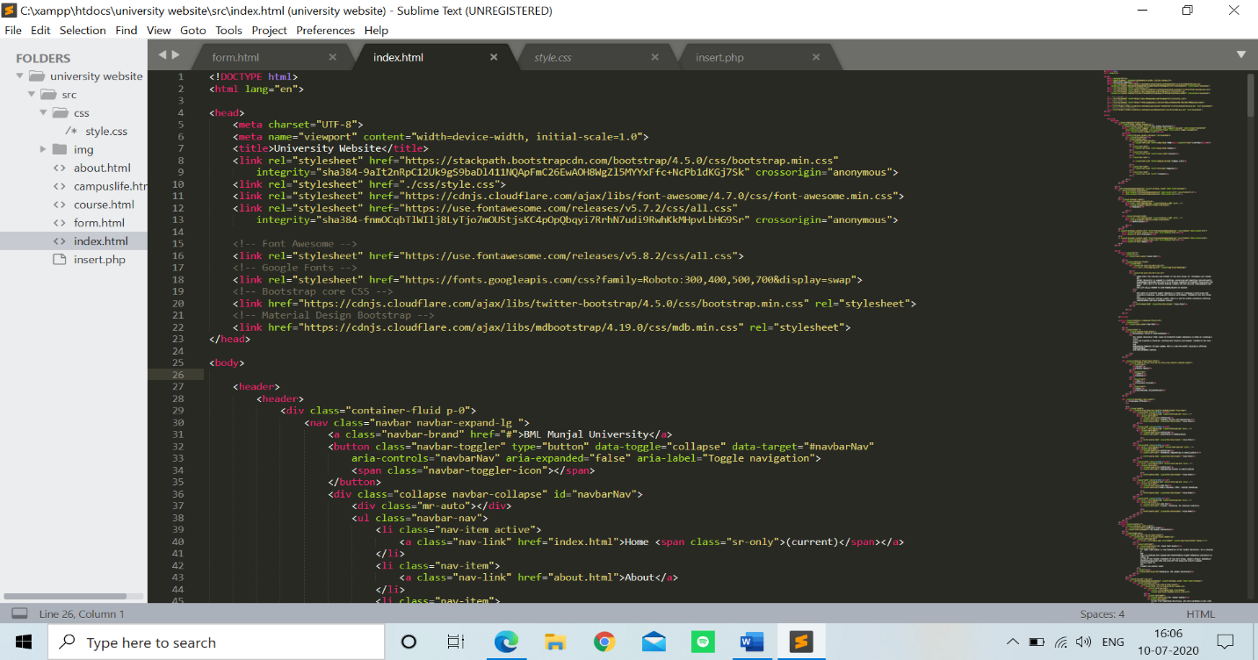

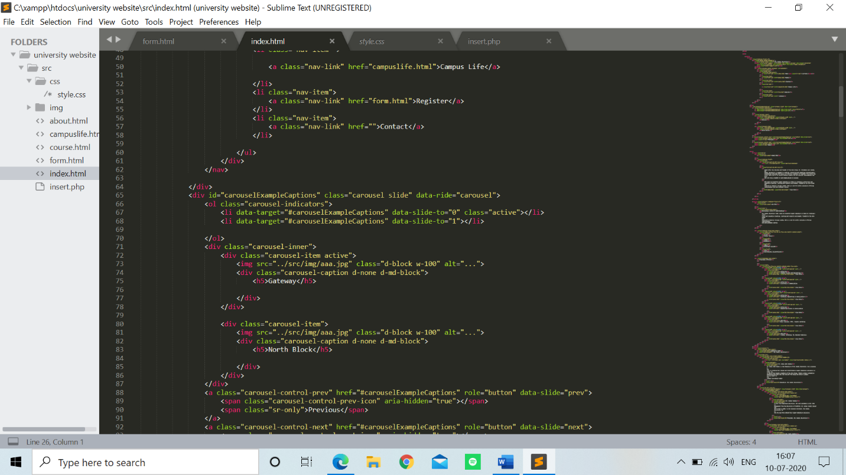

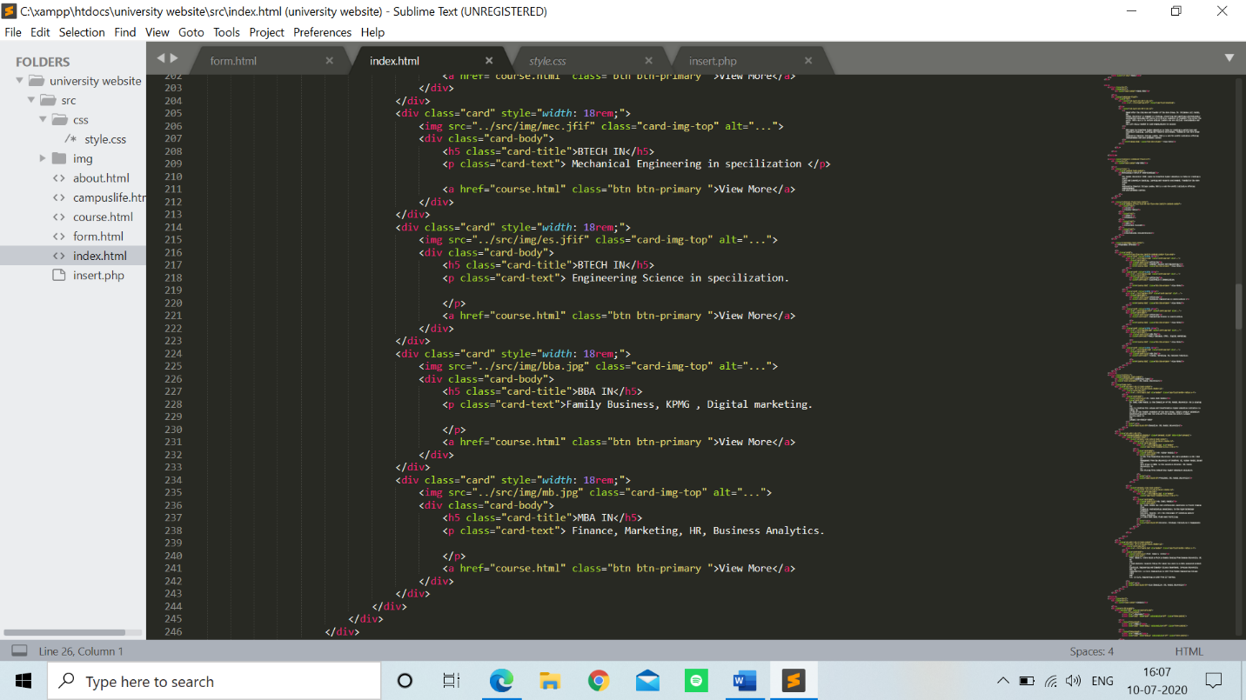

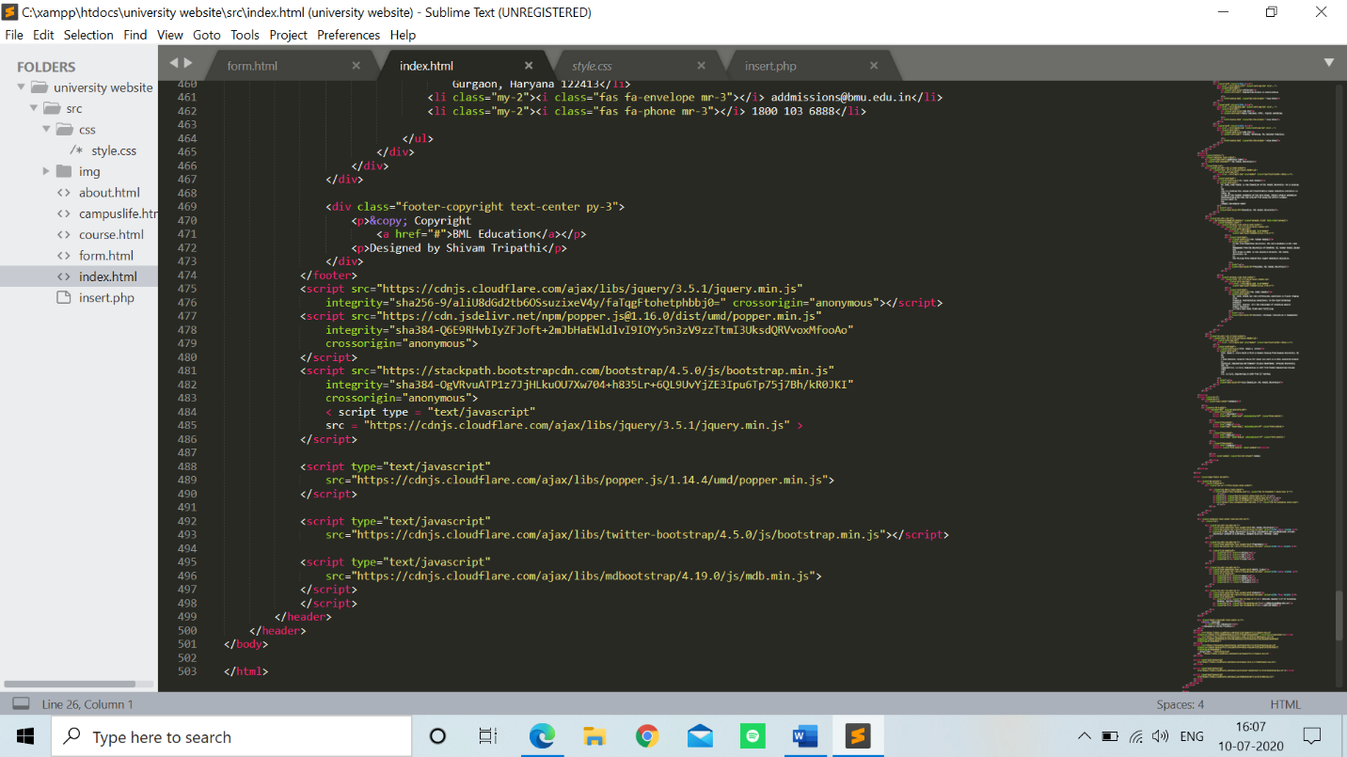

**Code**

Attaching my GitHub File for reference of code

<https://github.com/Shivamtripathi13/PS2-PROJECT/tree/master/src>

**Conclusion**

This internship helped me to gain the knowledge on web development and it was amazing, and I gained good experience. My internship at verzeo helped me to learn a lot about the web development. The work I done need more improvements and it can be improve by getting the opportunity. As It was my first experience of internship in web development and I can say that whatever time I spent in research and discovering it was well worth it and I find the solution to make my website. While doing this internship many things I learnt but the two best things were time-management skill and self-motivation. By the end of my internship I created a website using the tools of web development which meet the expectation of both user and admin. At last I would like to convey my thanks to my college BML Munjal University for providing this opportunity.

**References**

* <https://getbootstrap.com/docs/4.0/getting-started/introduction/>
* <https://www.mysql.com/>
* <https://www.w3schools.com/>
* <https://www.tutorialspoint.com/index.htm>
* <https://www.udemy.com/>
* <https://www.coursera.org/programs/bml-munjal-university-on-coursera-uoa7d>